Weekly Lesson Plans
4Jan | Learning Target:  Classroom Management, Syllabus, & Standards  - Google Drive  - Google Classroom Invite  - Assignments & Attachments  - Adobe Creative Cloud Suite  - Snow Days (eLearning)
5Jan | Learning Target: Web Design (Theory & Techniques).  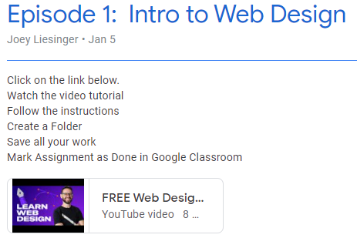
6Jan | Learning Target: Web Design (Theory & Techniques).  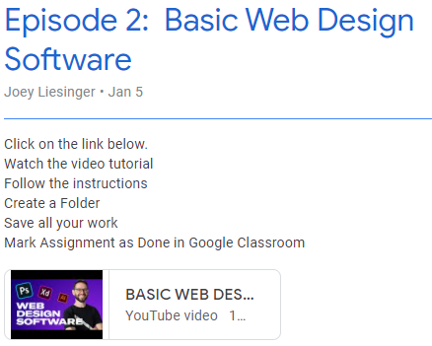
7Jan | Learning Target: Web Design (Theory & Techniques).  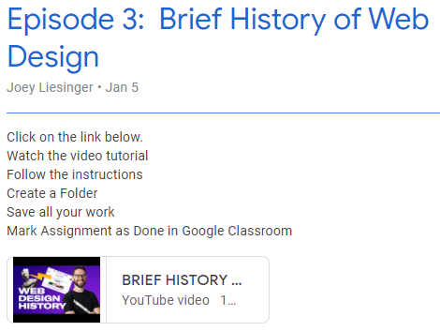
8Jan | Learning Target: Web Design (Theory & Techniques).  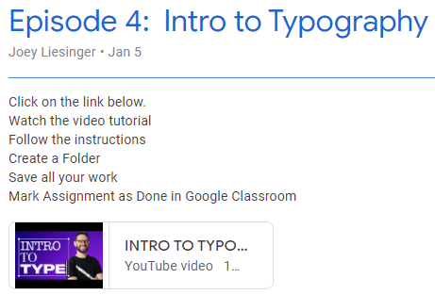
11Jan | Learning Target: Web Design (Theory & Techniques).  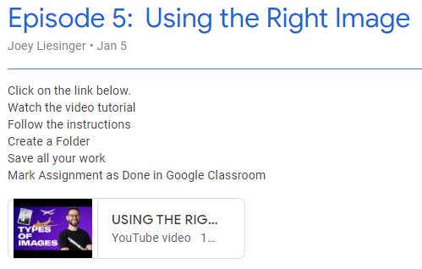
12Jan | Learning Target: Web Design (Theory & Techniques).  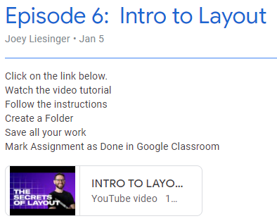
13Jan | Learning Target: Web Design (Theory & Techniques).  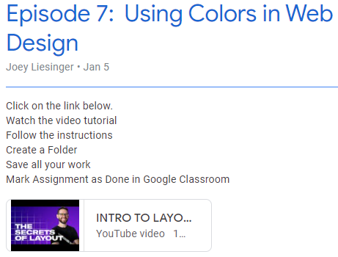
14Jan | Learning Target: Web Design (Theory & Techniques).  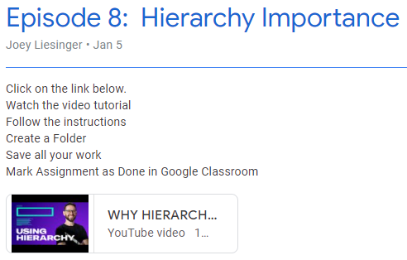
15Jan  Snow Day  eLearning | Learning Target: Web Design (Theory & Techniques).  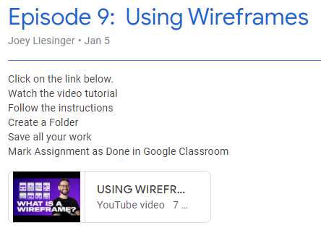  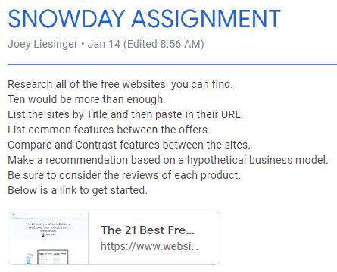
19Jan | Learning Target: Web Design (Theory & Techniques).  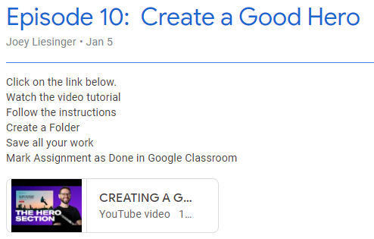
20Jan | Learning Target: Web Design (Theory & Techniques).  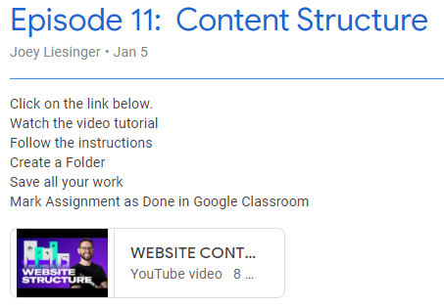
21Jan | Learning Target: Web Design (Theory & Techniques).  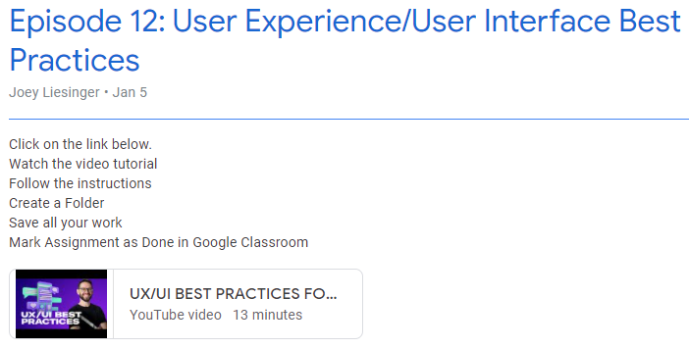
22Jan | Learning Target: Web Design (Theory & Techniques).  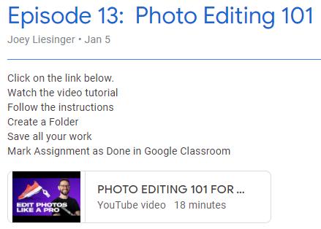
25Jan | Learning Target: Web Design (Theory & Techniques).  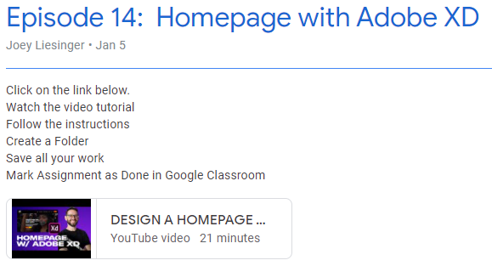
26Jan | Learning Target: Web Design (Theory & Techniques).  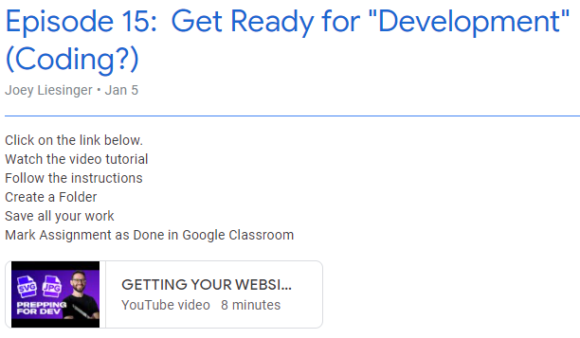
27Jan | Learning Target: Web Design (Theory & Techniques).  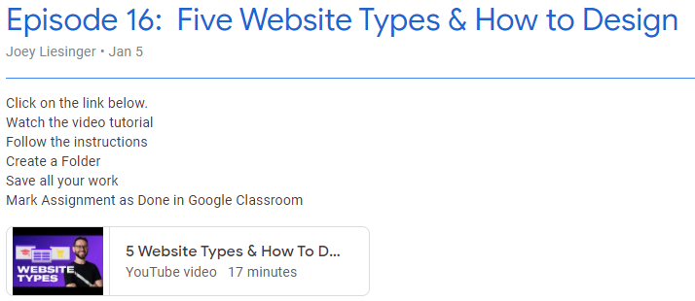
28Jan | Learning Target: Web Design (Theory & Techniques).  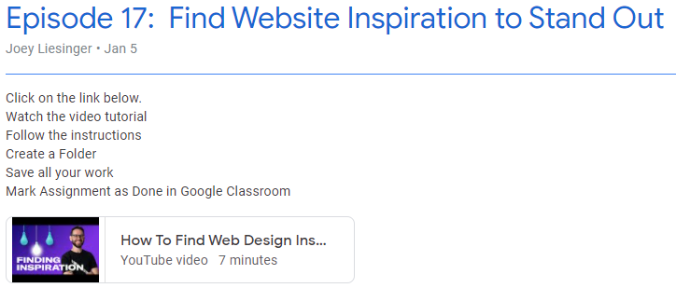
29Jan | Learning Target: Web Design (Theory & Techniques).  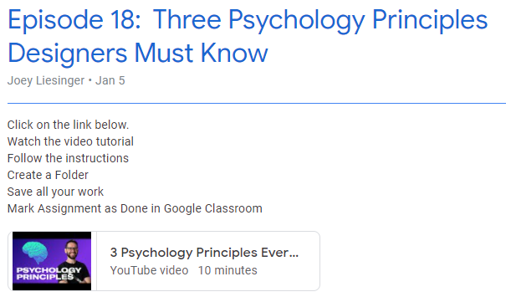
1Feb | Learning Target: Web Design (Theory & Techniques).  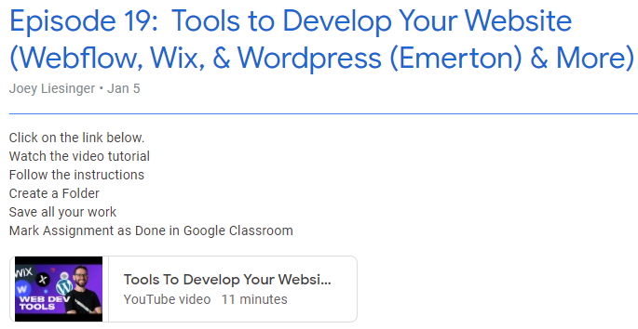
2Feb | Learning Target: Web Design (Theory & Techniques).  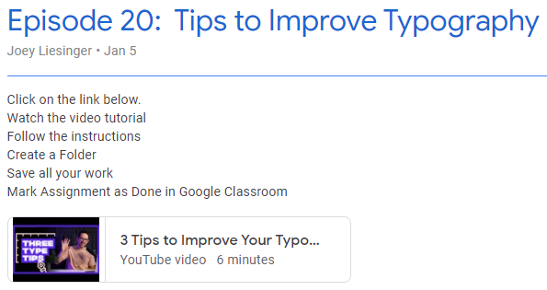
3Feb  Early Release | Learning Target: DREAMWEAVER CC  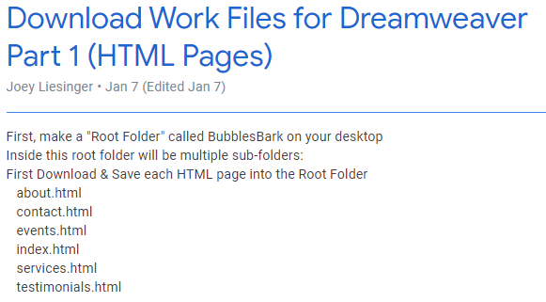  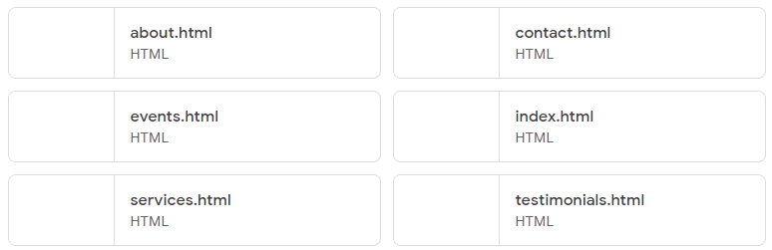  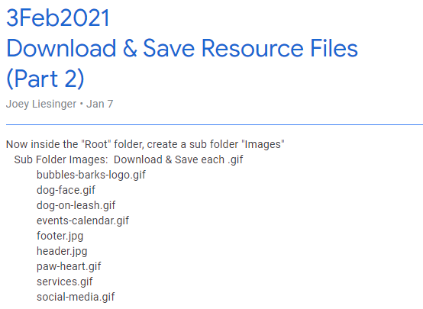  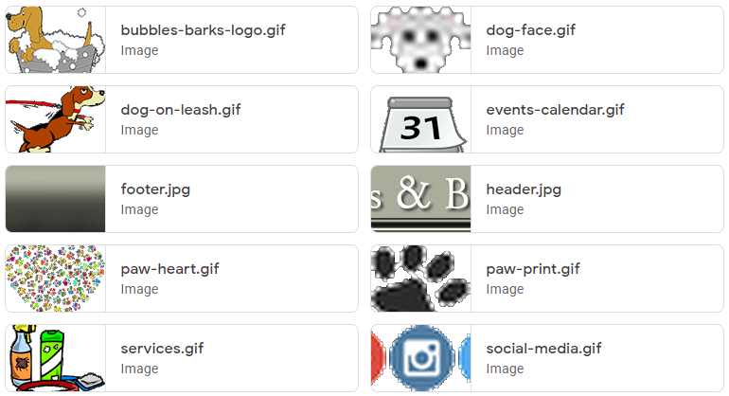  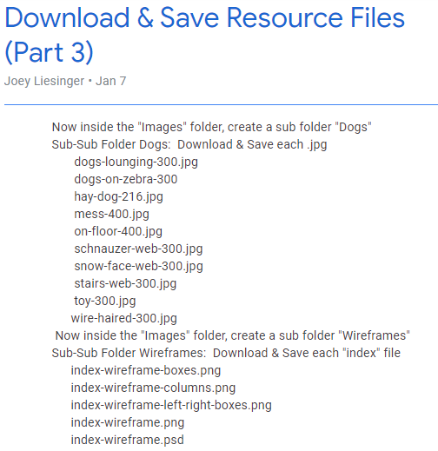  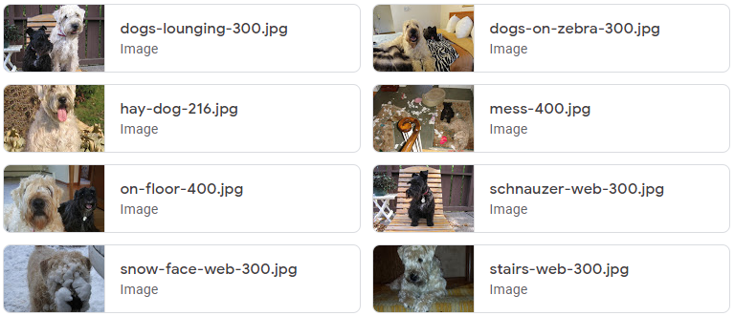  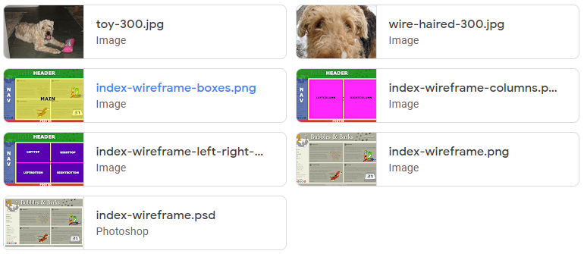  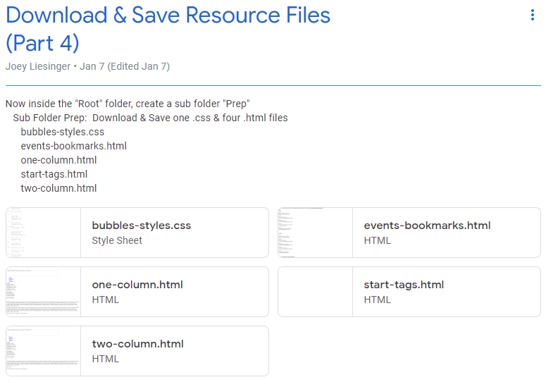  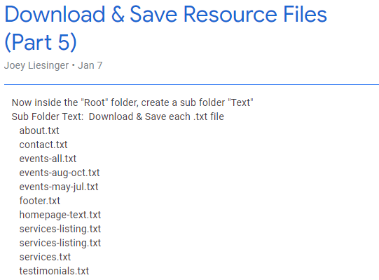  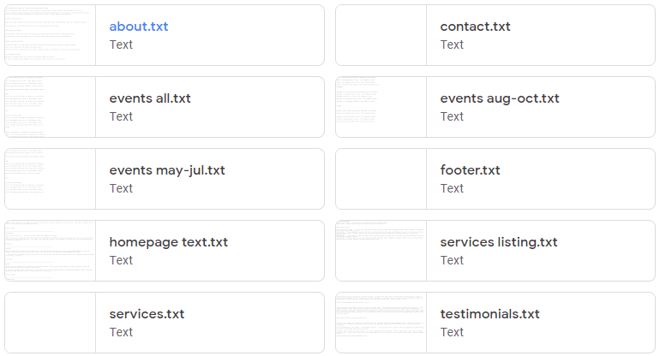  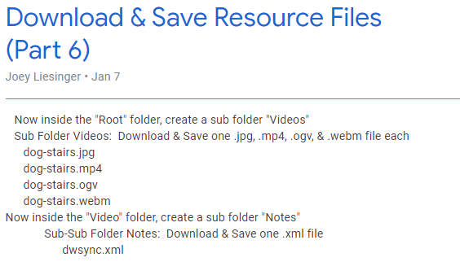  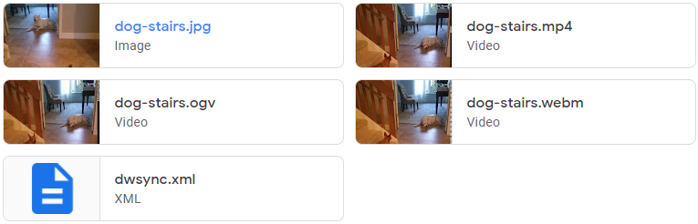
4Feb | Learning Target: DREAMWEAVER CC  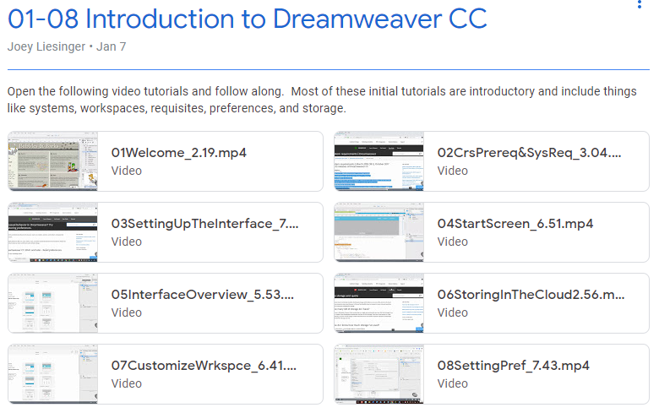
5Feb | Learning Target: DREAMWEAVER CC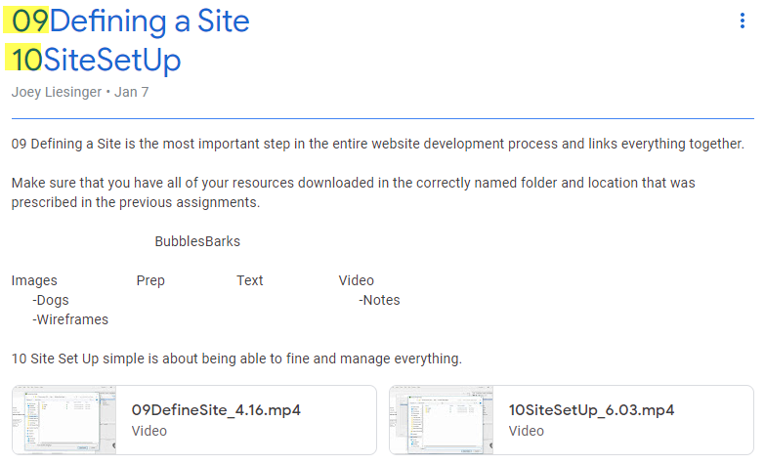
8Feb | Learning Target: DREAMWEAVER CC 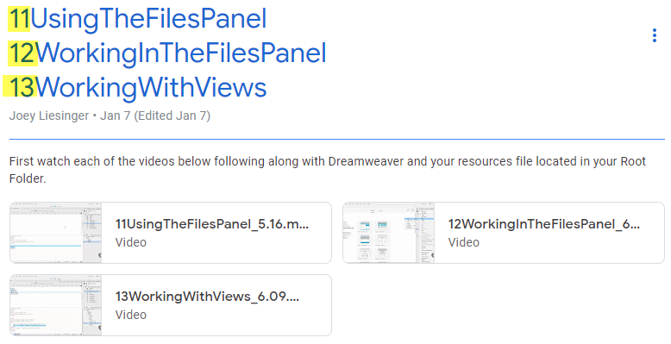
9Feb | Learning Target: DREAMWEAVER CC 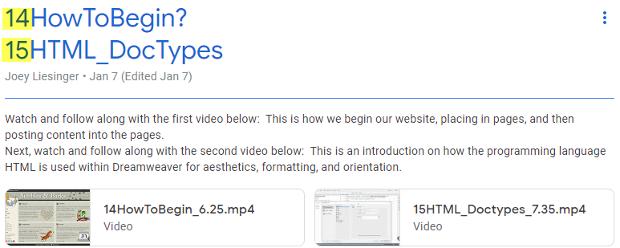
10Feb | Learning Target: DREAMWEAVER CC 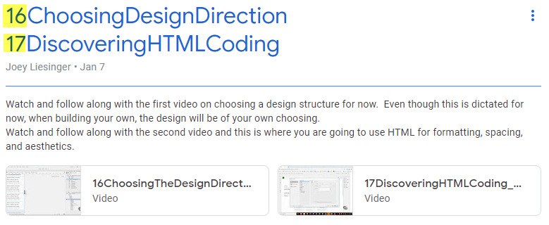
11Feb | Learning Target: DREAMWEAVER CC 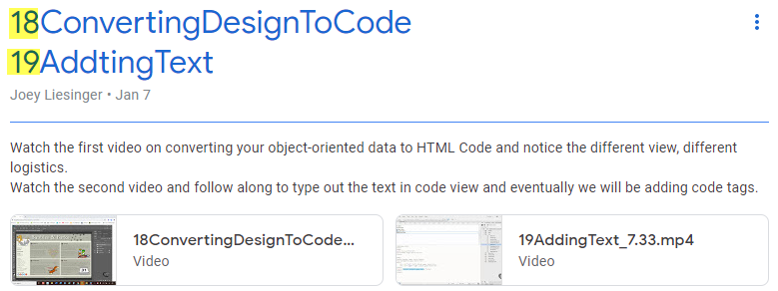
16Feb | Learning Target: DREAMWEAVER CC 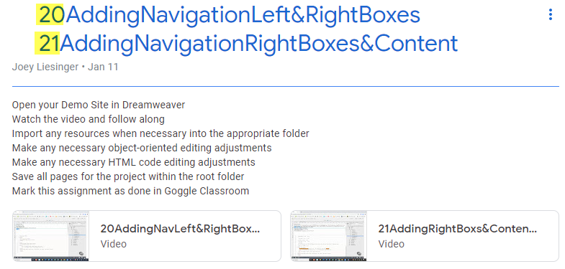
17Feb | Learning Target: DREAMWEAVER CC 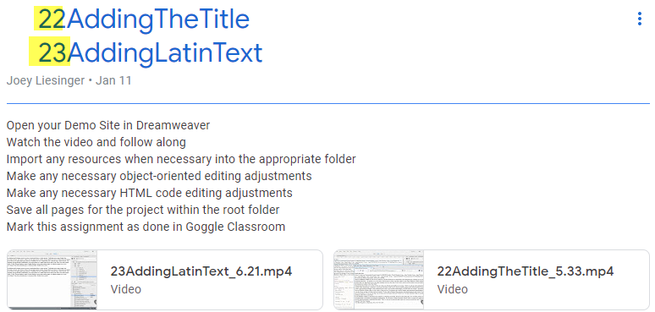
18Feb | Learning Target: DREAMWEAVER CC 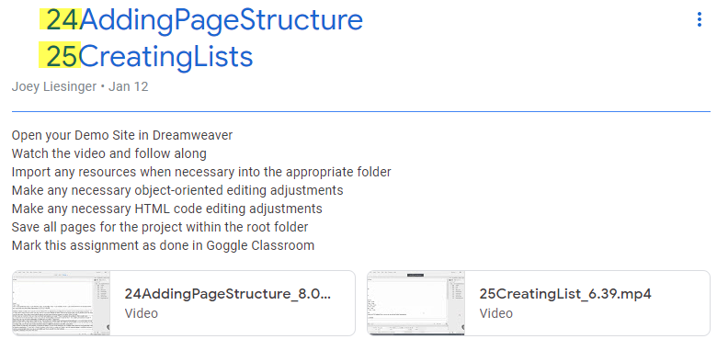
19Feb | Learning Target: DREAMWEAVER CC 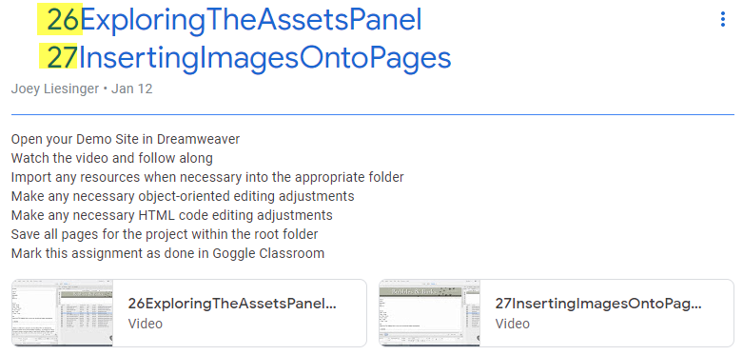
22Feb | Learning Target: DREAMWEAVER CC 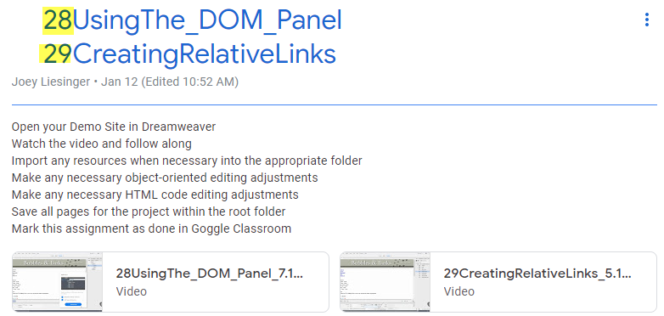
23Feb | Learning Target: DREAMWEAVER CC 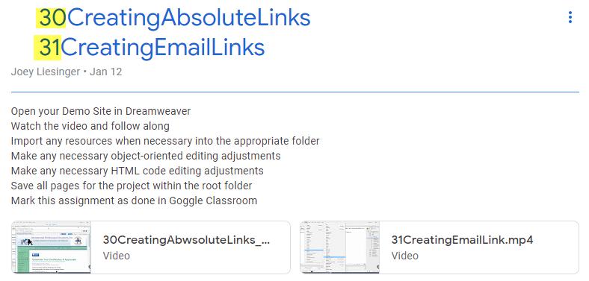
24Feb | Learning Target: DREAMWEAVER CC 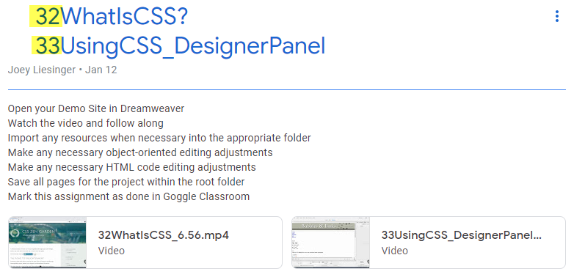
25Feb | Learning Target: DREAMWEAVER CC 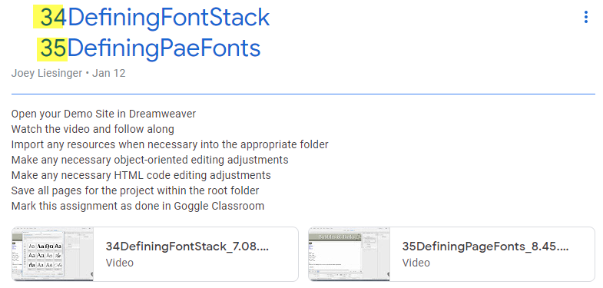
26Feb | Learning Target: DREAMWEAVER CC 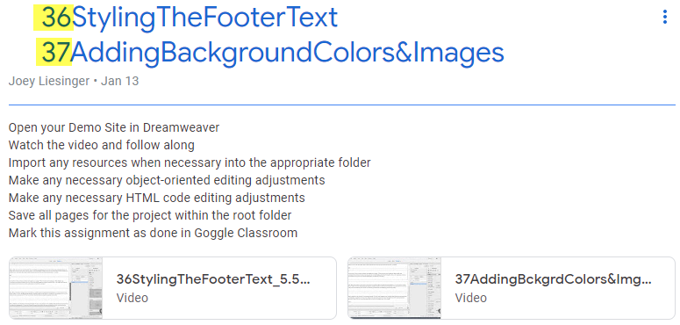
1Mar | Learning Target: DREAMWEAVER CC 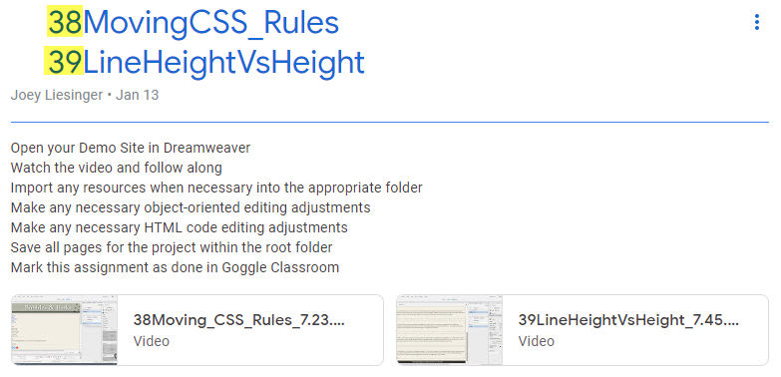
2Mar | Learning Target: DREAMWEAVER CC 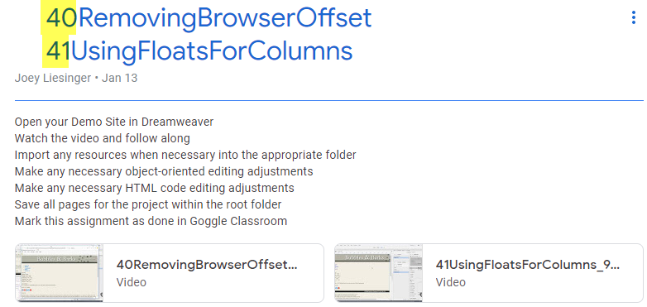
3Mar  Early Release | Learning Target: DREAMWEAVER CC 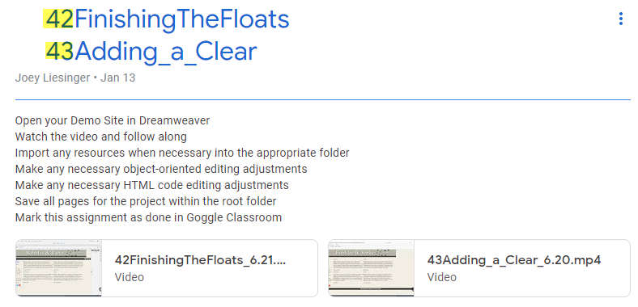
4Mar | Learning Target: DREAMWEAVER CC 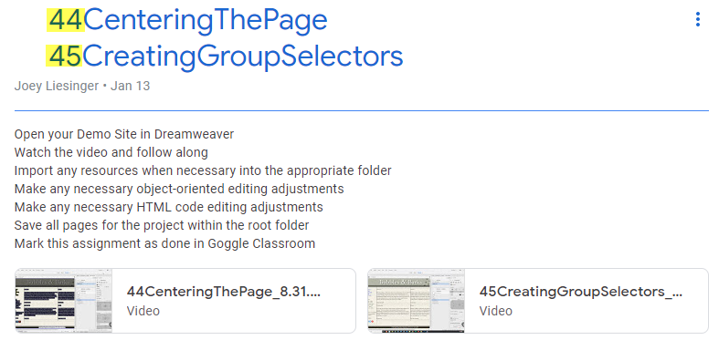
5Mar | Learning Target: DREAMWEAVER CC 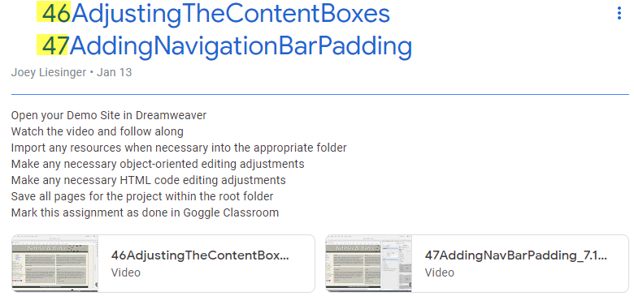
8Mar | Learning Target: DREAMWEAVER CC 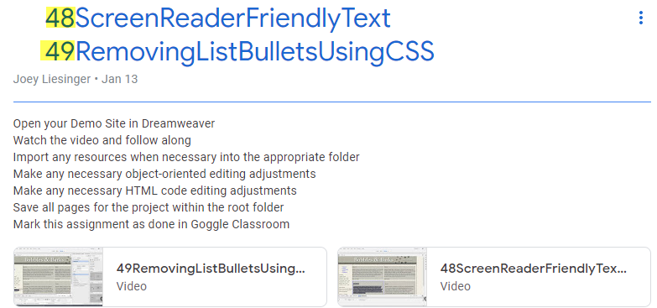
9Mar | Learning Target: DREAMWEAVER CC 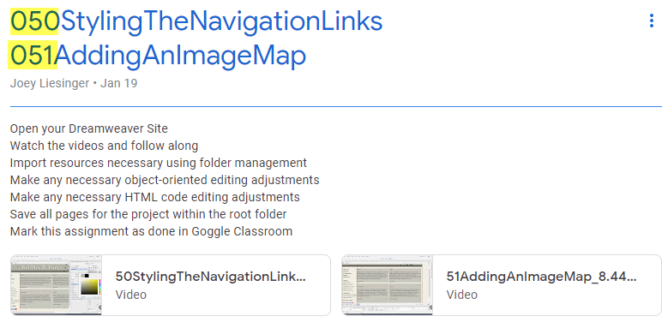
10Mar | Learning Target: DREAMWEAVER CC 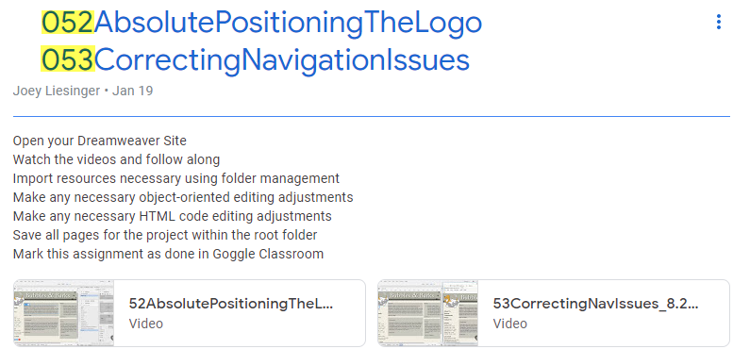
11Mar | Learning Target: DREAMWEAVER CC 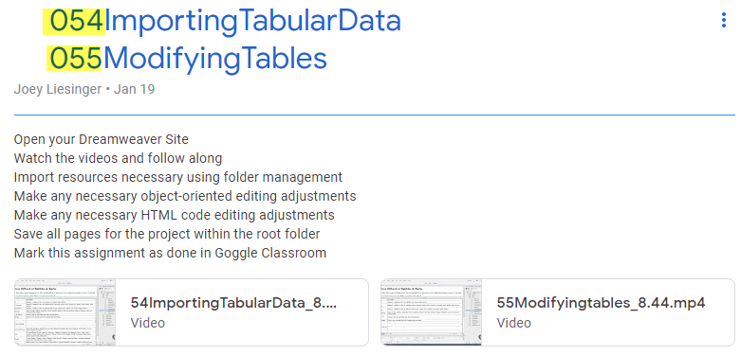
12Mar | Learning Target: DREAMWEAVER CC 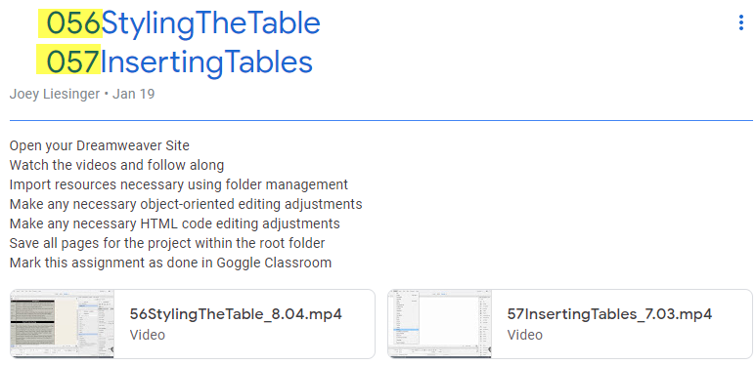
15Mar  P/T Conf | Learning Target: DREAMWEAVER CC 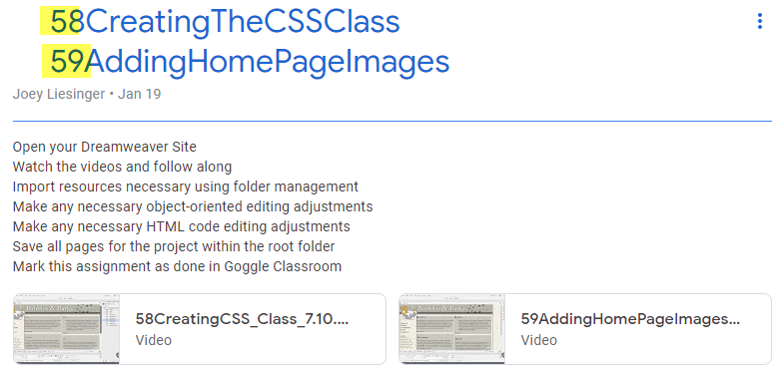
16Mar  P/T Conf | Learning Target: DREAMWEAVER CC 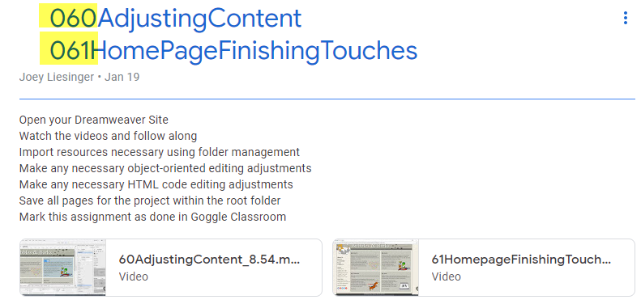
17Mar | Learning Target: DREAMWEAVER CC 
22Mar | Learning Target: DREAMWEAVER CC 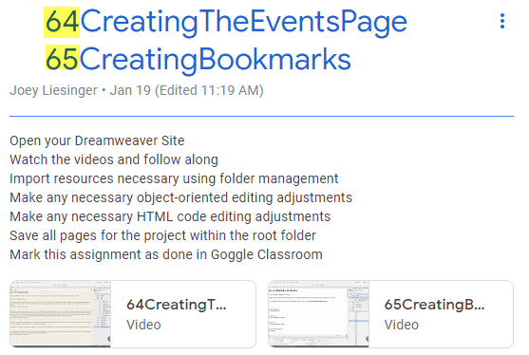
23Mar | Learning Target: DREAMWEAVER CC 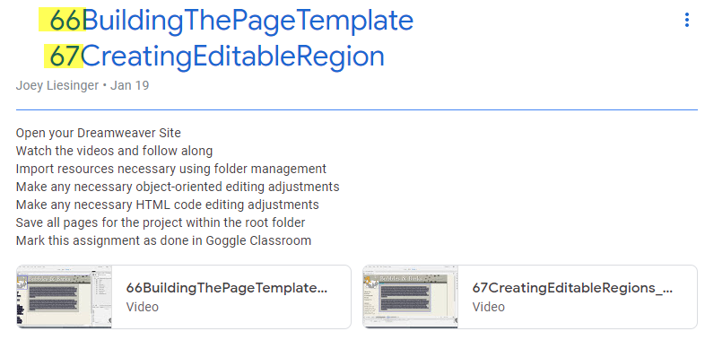
24Mar | Learning Target: DREAMWEAVER CC 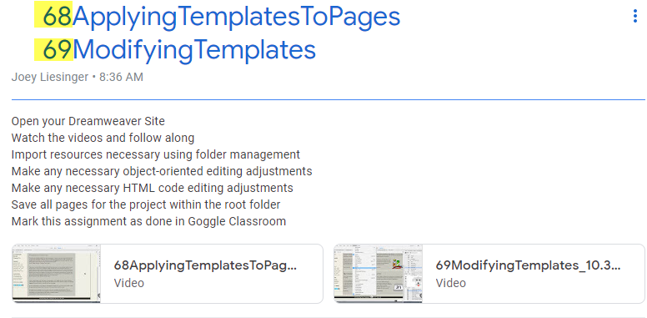
25Mar | Learning Target: DREAMWEAVER CC 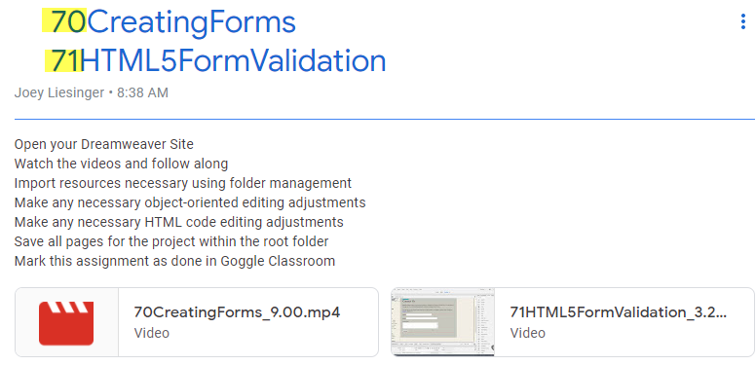
26Mar | Learning Target: DREAMWEAVER CC 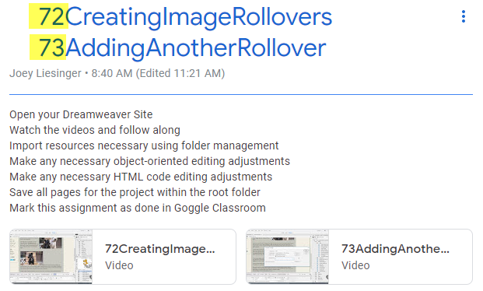
29Mar | Learning Target: DREAMWEAVER CC 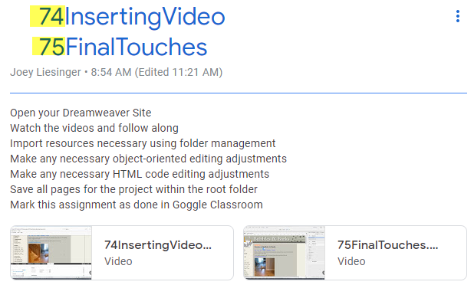
30Mar | Learning Target: DREAMWEAVER CC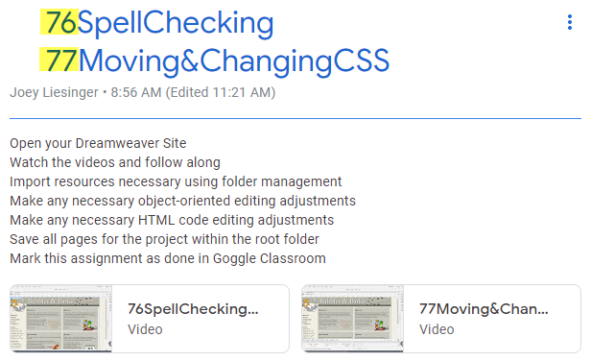
31Mar | Learning Target: DREAMWEAVER CC 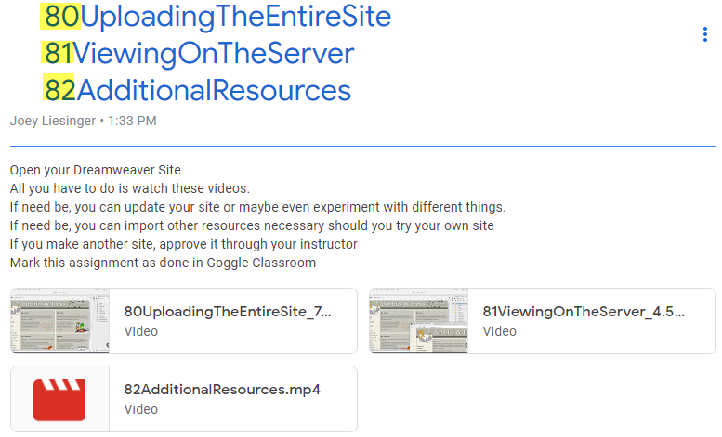
1Apr | Learning Target: WORDPRESS
6Apr | Learning Target: WORDPRESS
7Apr | Learning Target: WORDPRESS
8Apr | Learning Target: WORDPRESS
9Apr | Learning Target: WORDPRESS
12Apr | Learning Target: WORDPRESS
13Apr | Learning Target: WORDPRESS
14Apr | Learning Target: WORDPRESS
15Apr | Learning Target: WORDPRESS
16Apr | Learning Target: WORDPRESS
19Apr | Learning Target: WORDPRESS
20Apr | Learning Target: WORDPRESS
21Apr | Learning Target: WORDPRESS
22Apr | Learning Target: WORDPRESS
23Apr | Learning Target: WORDPRESS
26Apr | Learning Target: WORDPRESS
27Apr | Learning Target: WORDPRESS
28Apr | Learning Target: WORDPRESS
29Apr | Learning Target: WORDPRESS
30Apr | Learning Target: WORDPRESS
3May | Learning Target: WORDPRESS
4May | Learning Target: WORDPRESS
5May  Early Release | Learning Target: WORDPRESS
6May | Learning Target: WORDPRESS
7May | Learning Target: WORDPRESS
10May | Final Exam: Project (Review)
11May | Final Exam: Project
12May | Final Exam: Project (Correct)
13May | Final Exam: Written (Review)
14May | Final Exam: Written
16May  Sunday | GRADUATION
17May | Final Exam: Written (Correct)
18May  Early Release | Checkout

